1. Membuat tampilan OS Android (Material Design)

Flutter Code :

* main.dart

import 'package:flutter/material.dart';

import 'package:flutter_platform_widget/DrawerScreen.dart';

import 'package:flutter_platform_widget/HomeScreen.dart';

import 'package:flutter_platform_widget/SettingsScreen.dart';

void main() {

runApp(const MyApp());

}

class MyApp extends StatelessWidget {

const MyApp({Key? key}) : super(key: key);

@override

Widget build(BuildContext context) {

return MaterialApp(

title: 'Flutter Platform Widget',

debugShowCheckedModeBanner: false,

theme: ThemeData(

brightness: Brightness.dark,

),

home: const MyHomePage(

title: 'MaterialApp',

),

);

}

}

class MyHomePage extends StatefulWidget {

const MyHomePage({Key? key, required this.title}) : super(key: key);

final String title;

@override

State<MyHomePage> createState() => _MyHomePageState();

}

class _MyHomePageState extends State<MyHomePage> {

int selectedIndex = 0;

final List<Widget> _list = [

const HomeScreen(),

const SettingsScreen(),

];

void onItemTapped(int index) {

setState(() {

selectedIndex = index;

});

}

@override

Widget build(BuildContext context) {

return Scaffold(

appBar: AppBar(

title: Text(widget.title),

),

drawer: const DrawerScreen(),

body: Center(

child: _list.elementAt(selectedIndex),

),

bottomNavigationBar: BottomNavigationBar(

items: const <BottomNavigationBarItem>[

BottomNavigationBarItem(

icon: Icon(Icons.home),

label: "Home",

),

BottomNavigationBarItem(

icon: Icon(Icons.settings),

label: "Settings",

),

],

currentIndex: selectedIndex,

selectedItemColor: Colors.green,

unselectedItemColor: Colors.grey,

showUnselectedLabels: true,

onTap: onItemTapped,

),

);

}

}

* HomeScreen.dart

import 'package:flutter/material.dart';

class HomeScreen extends StatelessWidget {

const HomeScreen({Key? key}) : super(key: key);

@override

Widget build(BuildContext context) {

return Center(

child: Column(

mainAxisAlignment: MainAxisAlignment.center,

children: const <Widget>[

Text("This is MaterialApp"),

],

),

);

}

}

* SettingsScreen.dart

import 'package:flutter/material.dart';

class SettingsScreen extends StatelessWidget {

const SettingsScreen({Key? key}) : super(key: key);

@override

Widget build(BuildContext context) {

return Center(

child: Column(

mainAxisAlignment: MainAxisAlignment.center,

children: const <Widget>[Text("This is Settings MaterialApp")],

),

);

}

}

* DrawerScreen.dart

import 'package:flutter/material.dart';

import 'package:flutter_platform_widget/DatePicker-ColorPicker-FilePicker/InteractiveWidget.dart';

import 'package:flutter_platform_widget/FlutterForm/Contacts.dart';

import 'package:flutter_platform_widget/ListViewPage.dart';

import 'package:flutter_platform_widget/MyFlutterApp/MyFlutterApp.dart';

class DrawerScreen extends StatelessWidget {

const DrawerScreen({Key? key}) : super(key: key);

@override

Widget build(BuildContext context) {

return Drawer(

child: ListView(

children: <Widget>[

DrawerListTile(

title: "Home",

onTilePressed: () {},

),

DrawerListTile(

title: "Settings",

onTilePressed: () {},

),

DrawerListTile(

title: "Listview",

onTilePressed: () {

Navigator.push(context,

MaterialPageRoute(builder: (context) => const ListViewPage()));

},

),

DrawerListTile(

title: "My Flutter App",

onTilePressed: () {

Navigator.push(context,

MaterialPageRoute(builder: (context) => const MyFlutterApp()));

},

),

DrawerListTile(

title: "Flutter Form",

onTilePressed: () {

Navigator.push(context,

MaterialPageRoute(builder: (context) => const Contacts()));

},

),

DrawerListTile(

title: "Interactive Widget",

onTilePressed: () {

Navigator.push(

context,

MaterialPageRoute(

builder: (context) => const InteractiveWidget(),

),

);

},

),

],

));

}

}

class DrawerListTile extends StatelessWidget {

// final IconData? iconData;

final String? title;

final VoidCallback? onTilePressed;

const DrawerListTile({Key? key, this.title, this.onTilePressed})

: super(key: key);

@override

Widget build(BuildContext context) {

return ListTile(

onTap: onTilePressed,

dense: true,

title: Text(

title!,

style: const TextStyle(fontSize: 16),

),

);

}

}

Output :

* Home Screen

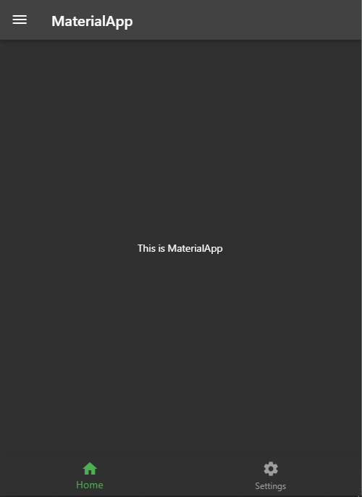

* Settings Screen

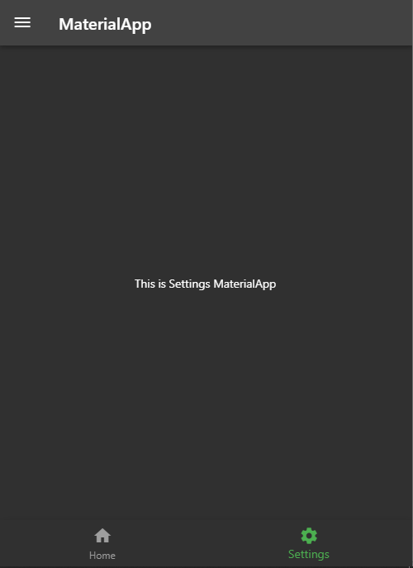

* Drawers Screen

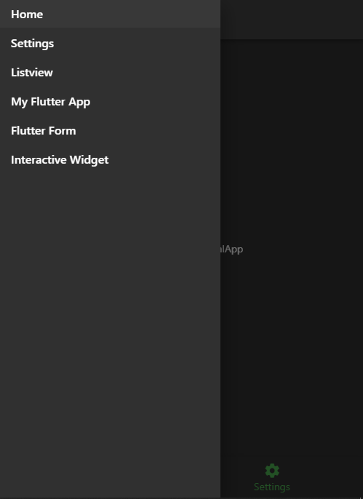

Penjelasan :

Disini saya menggunakan index pada navigation bar untuk berpindah halaman ketika button navigation bar di klik, sehingga button home dan settings pada navigation bar dapat digunakan untuk berpindah halaman dari home screen ke settings screen dan sebaliknya.

Untuk halaman home screen dan settings screen saya bedakan file nya dan juga drawers screen saya juga bedakan filenya. Untuk drawers screen dapat di akses dari tombol drawer pada pojok kiri atas. Untuk tombol home dan settings pada drawers belum saya aktifkan navigationnya, sehingga tombol home dan settings pada drawers tidak dapat beralih halaman. Untuk tombol lainnya pada drawers screen seperti listview, myflutterapp, flutter form dan interactive widget nya sudah saya aktifkan navigationnya sehingga dapat beralih ke halaman lain.

1. Setelah berhasil membuat sebuah tampilan OS Android dan di screenshot, ubah tampilan pada body aplikasi menjadi seperti dibawah ini menggunakan LISTVIEW!

* UserModel.dart

class UserModel {

final String name;

final String phoneNumber;

UserModel(

{required this.name,

required this.phoneNumber,

});

}

final List<UserModel> userList = [

UserModel(

name: "Leanne Graham",

phoneNumber: "1-770-736-8031 x56442",

),

UserModel(

name: "Ervin Howell",

phoneNumber: "010-692-6593 x09125",

),

UserModel(

name: "Clementine Bauch",

phoneNumber: "1-463-123-4447",

),

UserModel(

name: "Patricia Lebsack",

phoneNumber: "493-170-9623 x156",

),

UserModel(

name: "Chelsey Dietrich",

phoneNumber: "(254)954-1289",

),

UserModel(

name: "Mrs. Dennis Schulist",

phoneNumber: "010-692-6593 x09125",

),

UserModel(

name: "Kurtis Weissnat",

phoneNumber: "210.067.6132",

)

];

* ListViewPage.dart

import 'package:flutter/material.dart';

import 'package:flutter_platform_widget/UserModel.dart';

class ListViewPage extends StatelessWidget {

const ListViewPage({Key? key}) : super(key: key);

@override

Widget build(BuildContext context) {

return Theme(

data: ThemeData(brightness: Brightness.light),

child: Scaffold(

appBar: AppBar(

backgroundColor: const Color(0xff6200EE),

title: const Center(child: Text("List View")),

actions: [

IconButton(

icon: const Icon(Icons.search),

onPressed: () {},

),

],

),

body: Padding(

padding: const EdgeInsets.only(top: 15),

child: ListView.separated(

itemBuilder: (ctx, i) {

return ListTile(

leading: CircleAvatar(

radius: 28,

backgroundColor: Colors.green,

child: Text(

userList[i].name[0],

style: const TextStyle(color: Colors.white),

),

),

title: Text(

userList[i].name,

style: const TextStyle(fontWeight: FontWeight.bold),

),

subtitle: Text(userList[i].phoneNumber),

);

},

separatorBuilder: (ctx, i) {

return const Divider();

},

itemCount: userList.length),

),

),

);

}

}

Output :

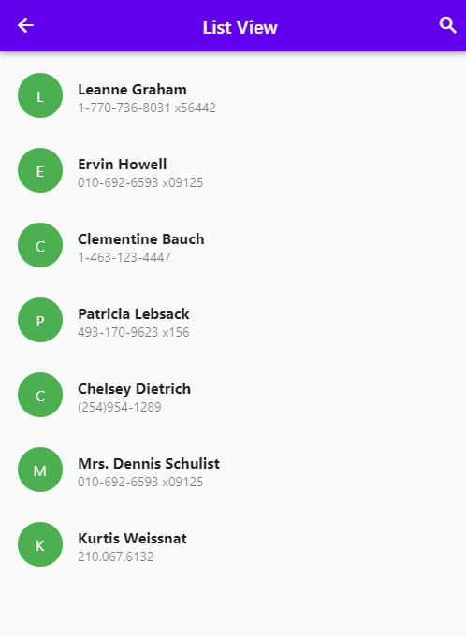

Penjelasan :

Untuk mengakses halaman listview ini dapat dengan cara klik ListView pada drawers screen. Disini saya menggunakan UserModel untuk menampung semua data user yang diperlukan dan data data user yang saya buat. Dan dari data data pada usermodel saya olah pada file ListViewPage.dart. Disini saya menggunakan ListView.separated untuk menggenerate list data sesuai dengan jumlah data yang ada yang telah dibuat pada usermodel. Disini untuk circle avatar saya tampilkan dan membuat initial huruf awal sesuai dengan nama user nya dengan menggunakan userList[i].name[0]. Dan pada title saya gunakan untuk menampilkan nama nama user, pada subtitle saya gunakan untuk menampilkan nomor telepon user